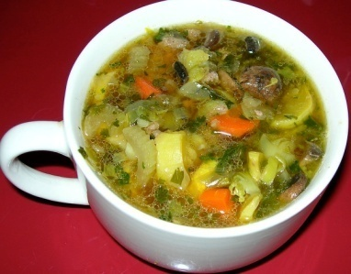
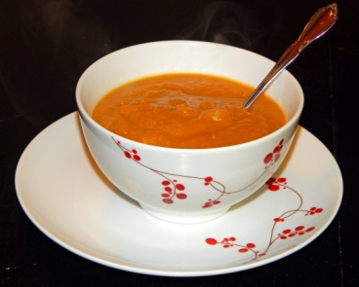
JANUARY SOUP SALE

The Middlecreek Area Community Center
Will be selling a different soup
each week the month of January.

ORDERS ARE DUE THE WEDNESDAY
BEFORE EACH WEEK.

Quarts $5.00
Pints $3.00

January 8 Hamburger Vegetable
January 15 Broccoli Cheddar
January 22 Chicken Corn Noodle
January 29 Loaded Potato

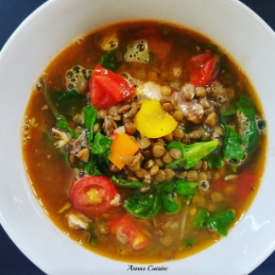
For more information call the MACC @
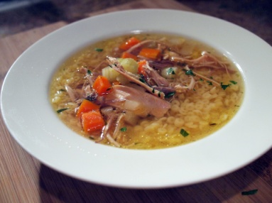
570-658-2276

